📘 KATAKANA + MNEMONIC (FULL)
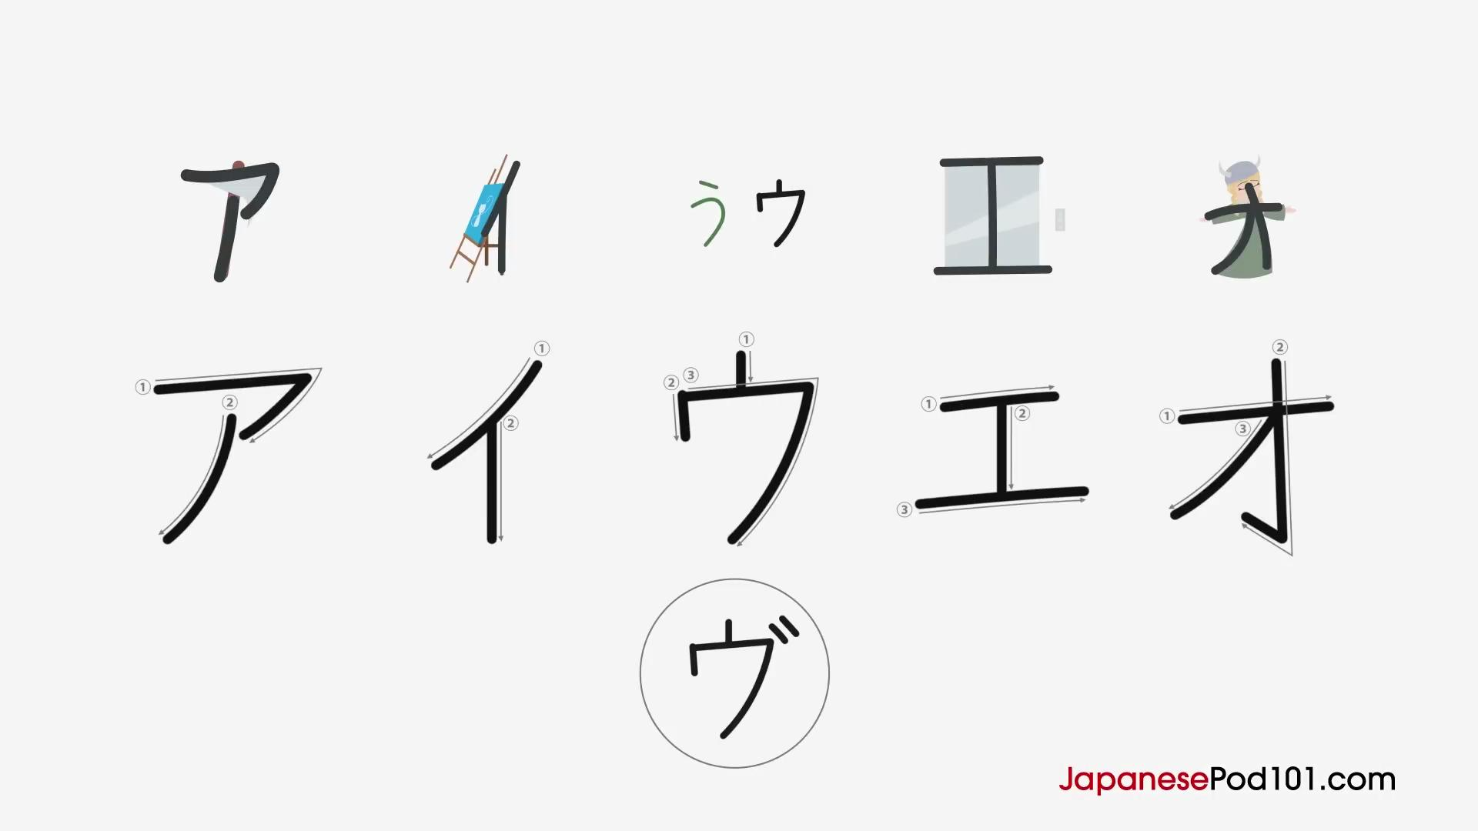
🔤 Vowel (Nguyên âm)
ア (a)
Mnemonic: Looks like an axe.
イ (i)
Mnemonic: Looks like an easel on its side.
ウ (u)
Mnemonic: Angular version of う (hiragana).
エ (e)
Mnemonic: Elevator doors.
オ (o)
Mnemonic: An opera singer.

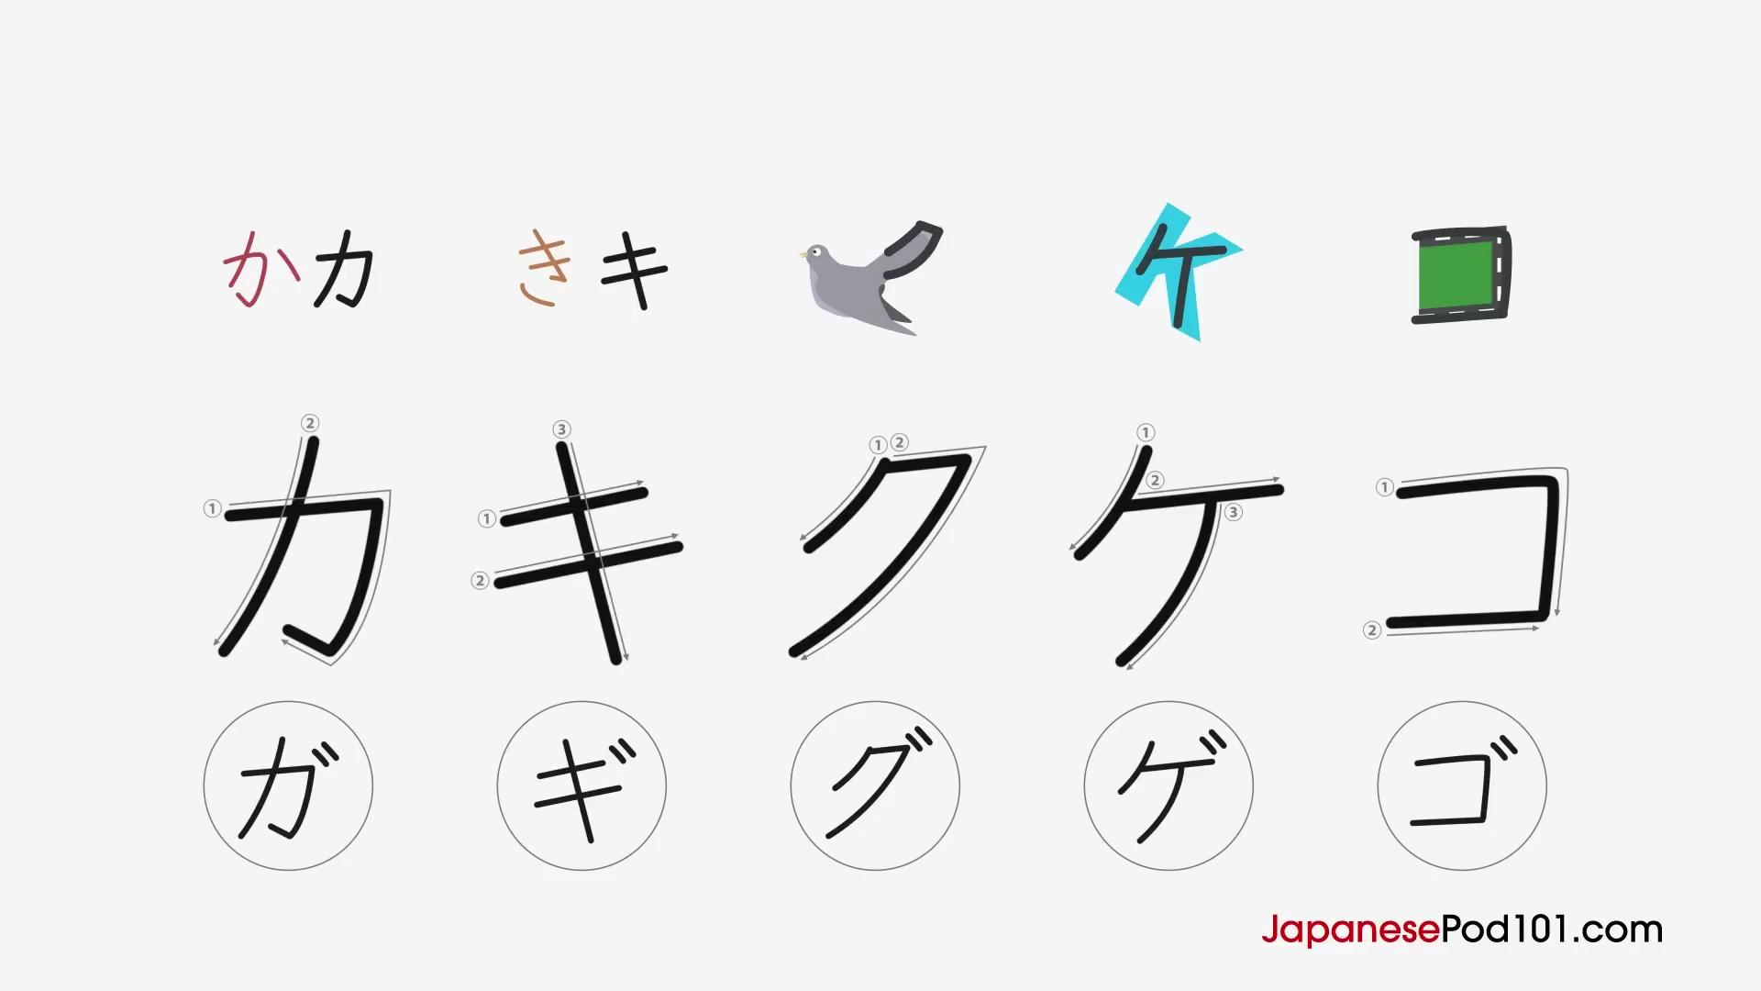

🔤 K Column
カ (ka)
Mnemonic: Angular version of か.
キ (ki)
Mnemonic: Like き but simpler (no bottom part).
ク (ku)
Mnemonic: A cuckoo’s tail.
ケ (ke)
Mnemonic: Looks like the letter K.
コ (ko)
Mnemonic: A road with two corners.

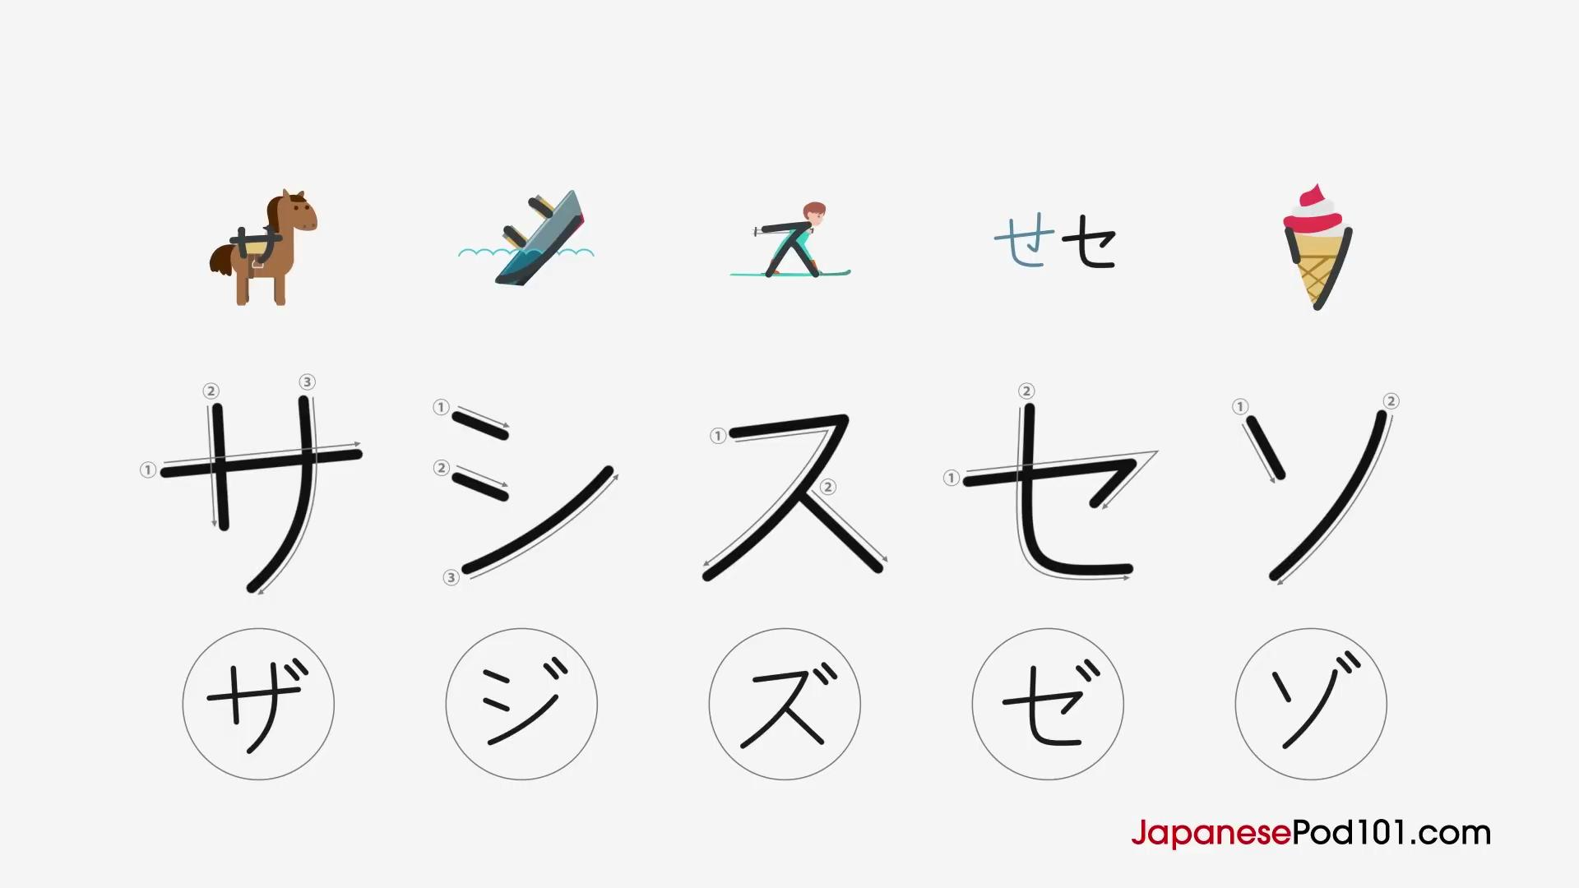
🔤 S Column
サ (sa)
Mnemonic: A saddle.
シ (shi)
Mnemonic: A sinking ship.
ス (su)
Mnemonic: A person skiing.
セ (se)
Mnemonic: Like せ but simpler.
ソ (so)
Mnemonic: A soft-serve ice cream.

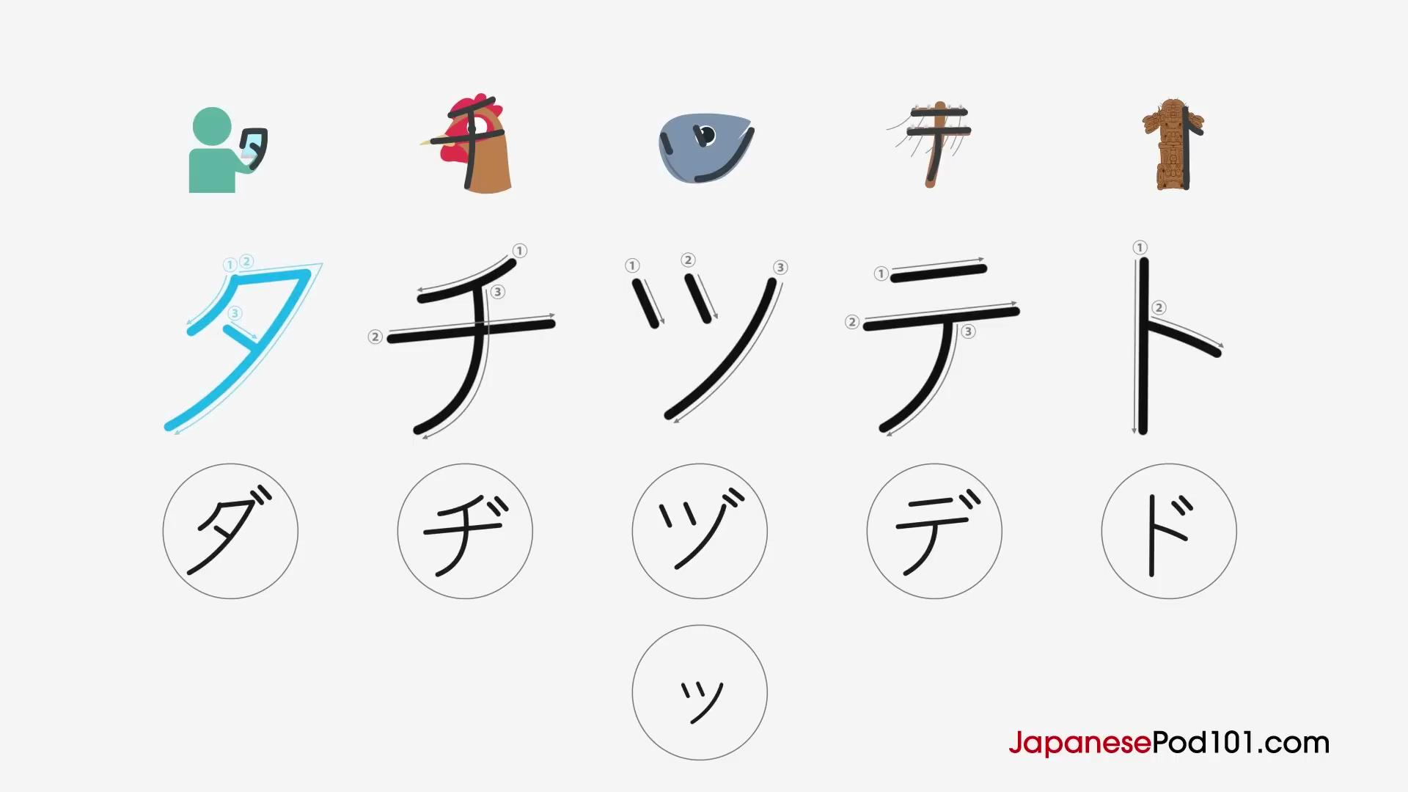

🔤 T Column
タ (ta)
Mnemonic: A person holding a tablet.
チ (chi)
Mnemonic: A chicken.
ツ (tsu)
Mnemonic: A tuna fish head.
テ (te)
Mnemonic: A bent telephone pole.
ト (to)
Mnemonic: A totem pole (side view).

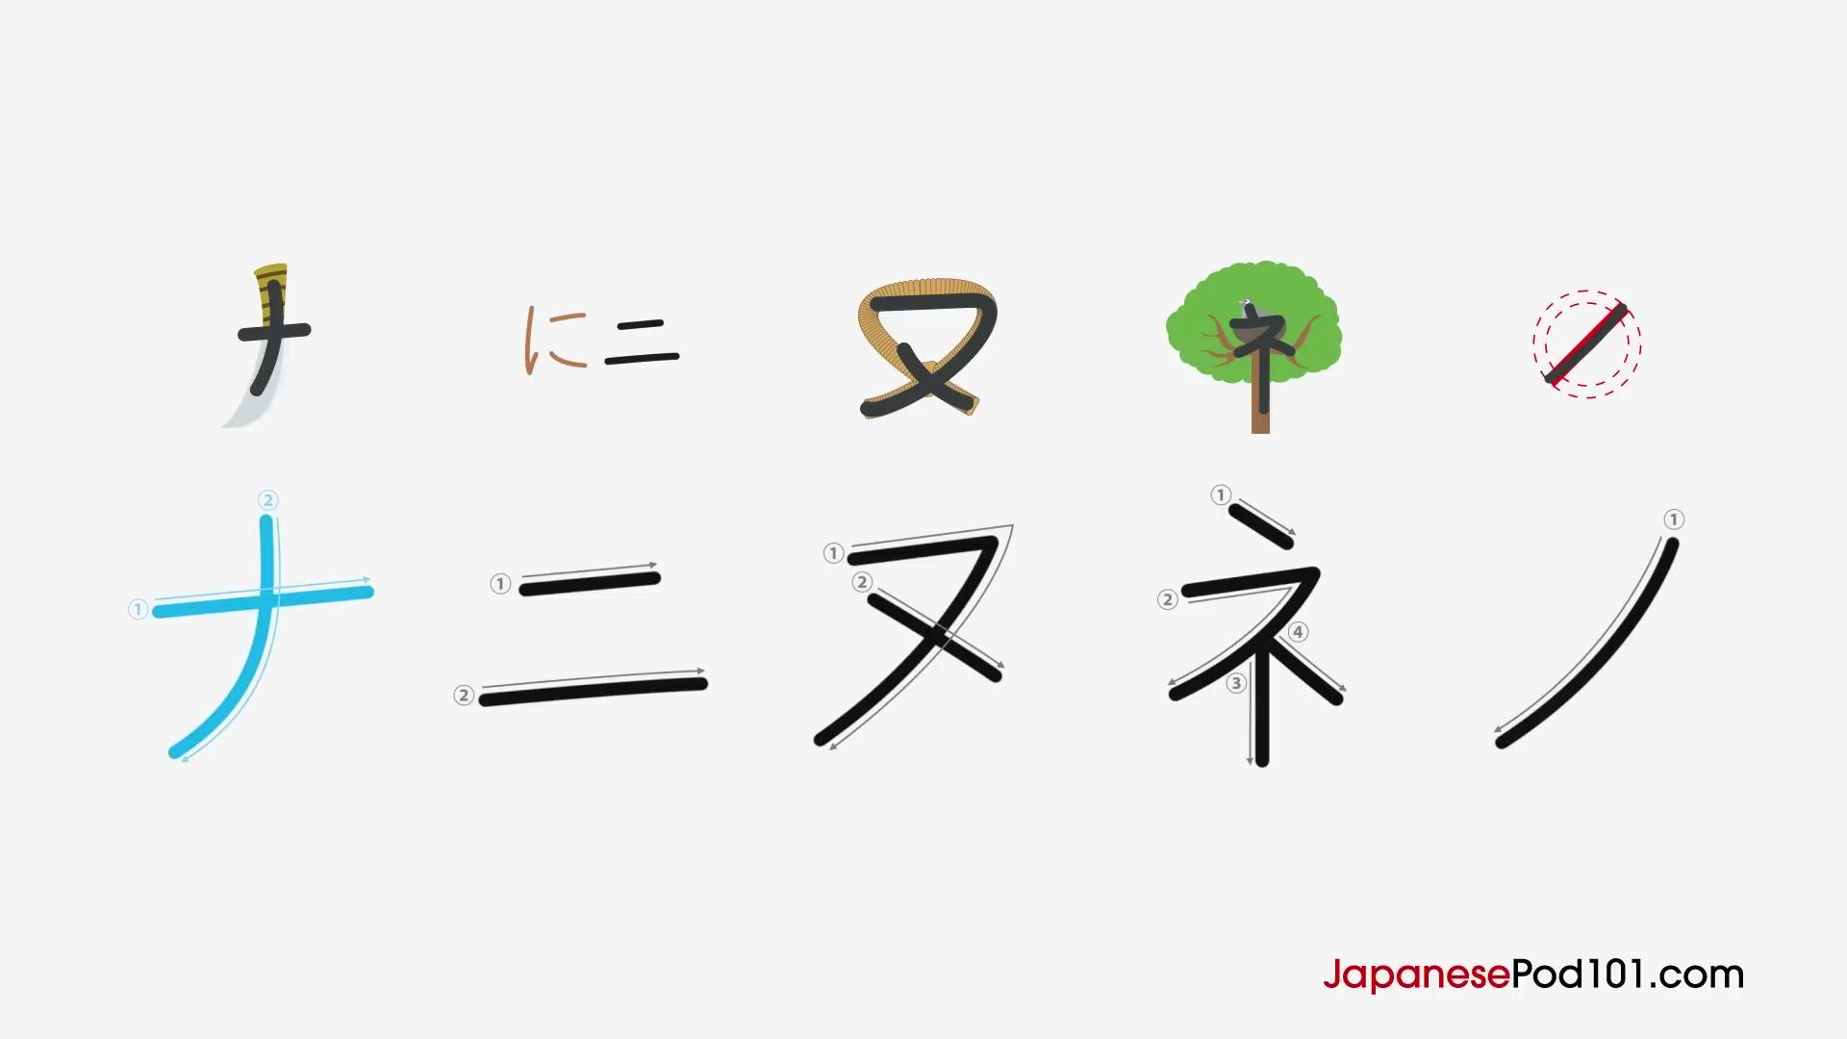

🔤 N Column
ナ (na)
Mnemonic: A curved knife.
ニ (ni)
Mnemonic: Straight version of に.
ヌ (nu)
Mnemonic: The word “news”.
ネ (ne)
Mnemonic: A nest in a tree.
ノ (no)
Mnemonic: A simple “no” sign.

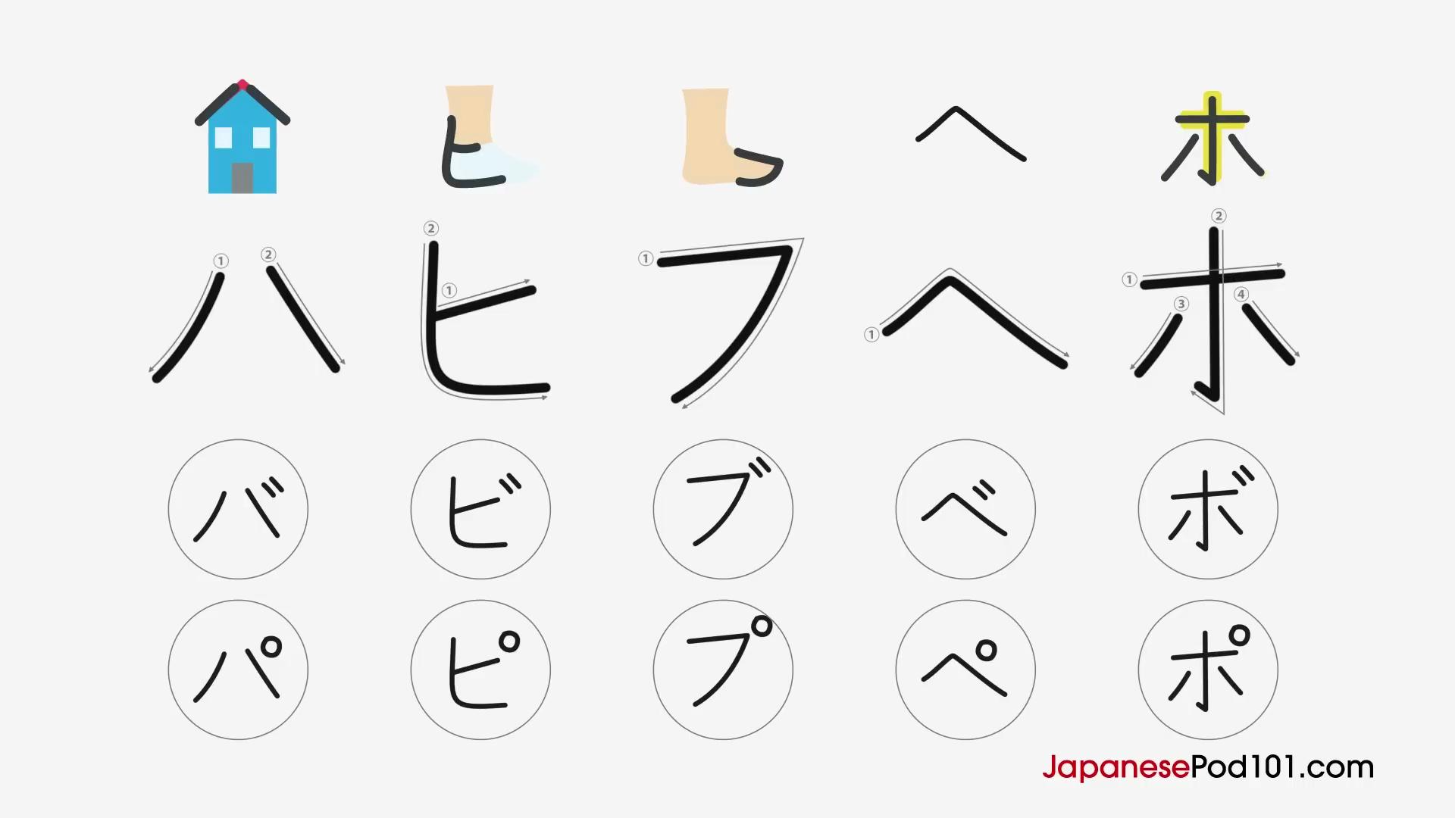

🔤 H Column
ハ (ha)
Mnemonic: A roof of a house.
ヒ (hi)
Mnemonic: The side of a heel.
フ (fu)
Mnemonic: The tip of a foot.
ヘ (he)
Mnemonic: Same as hiragana へ.
ホ (ho)
Mnemonic: A shining cross.

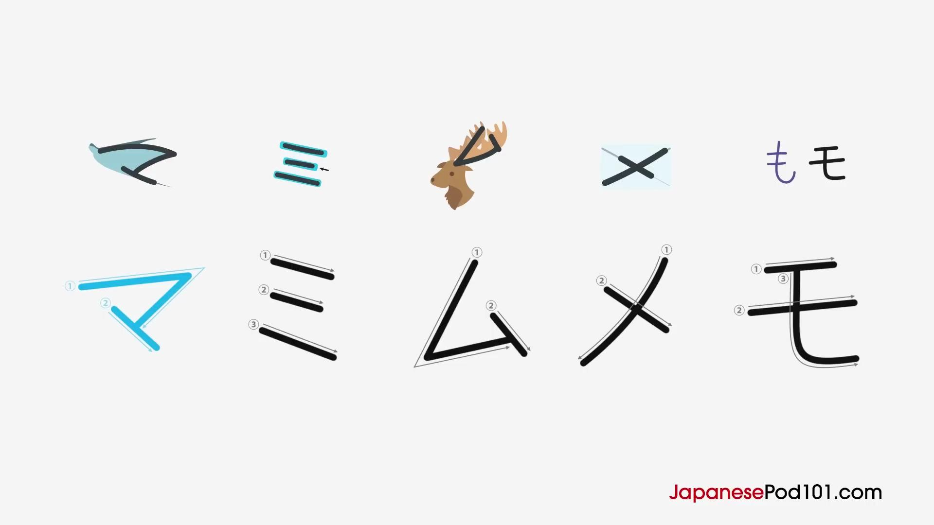

🔤 M Column
マ (ma)
Mnemonic: A manta ray.
ミ (mi)
Mnemonic: Look for the middle line.
ム (mu)
Mnemonic: Moose antlers.
メ (me)
Mnemonic: A box = “mail”.
モ (mo)
Mnemonic: Like も but lines don’t cross.

🔤 Y Column
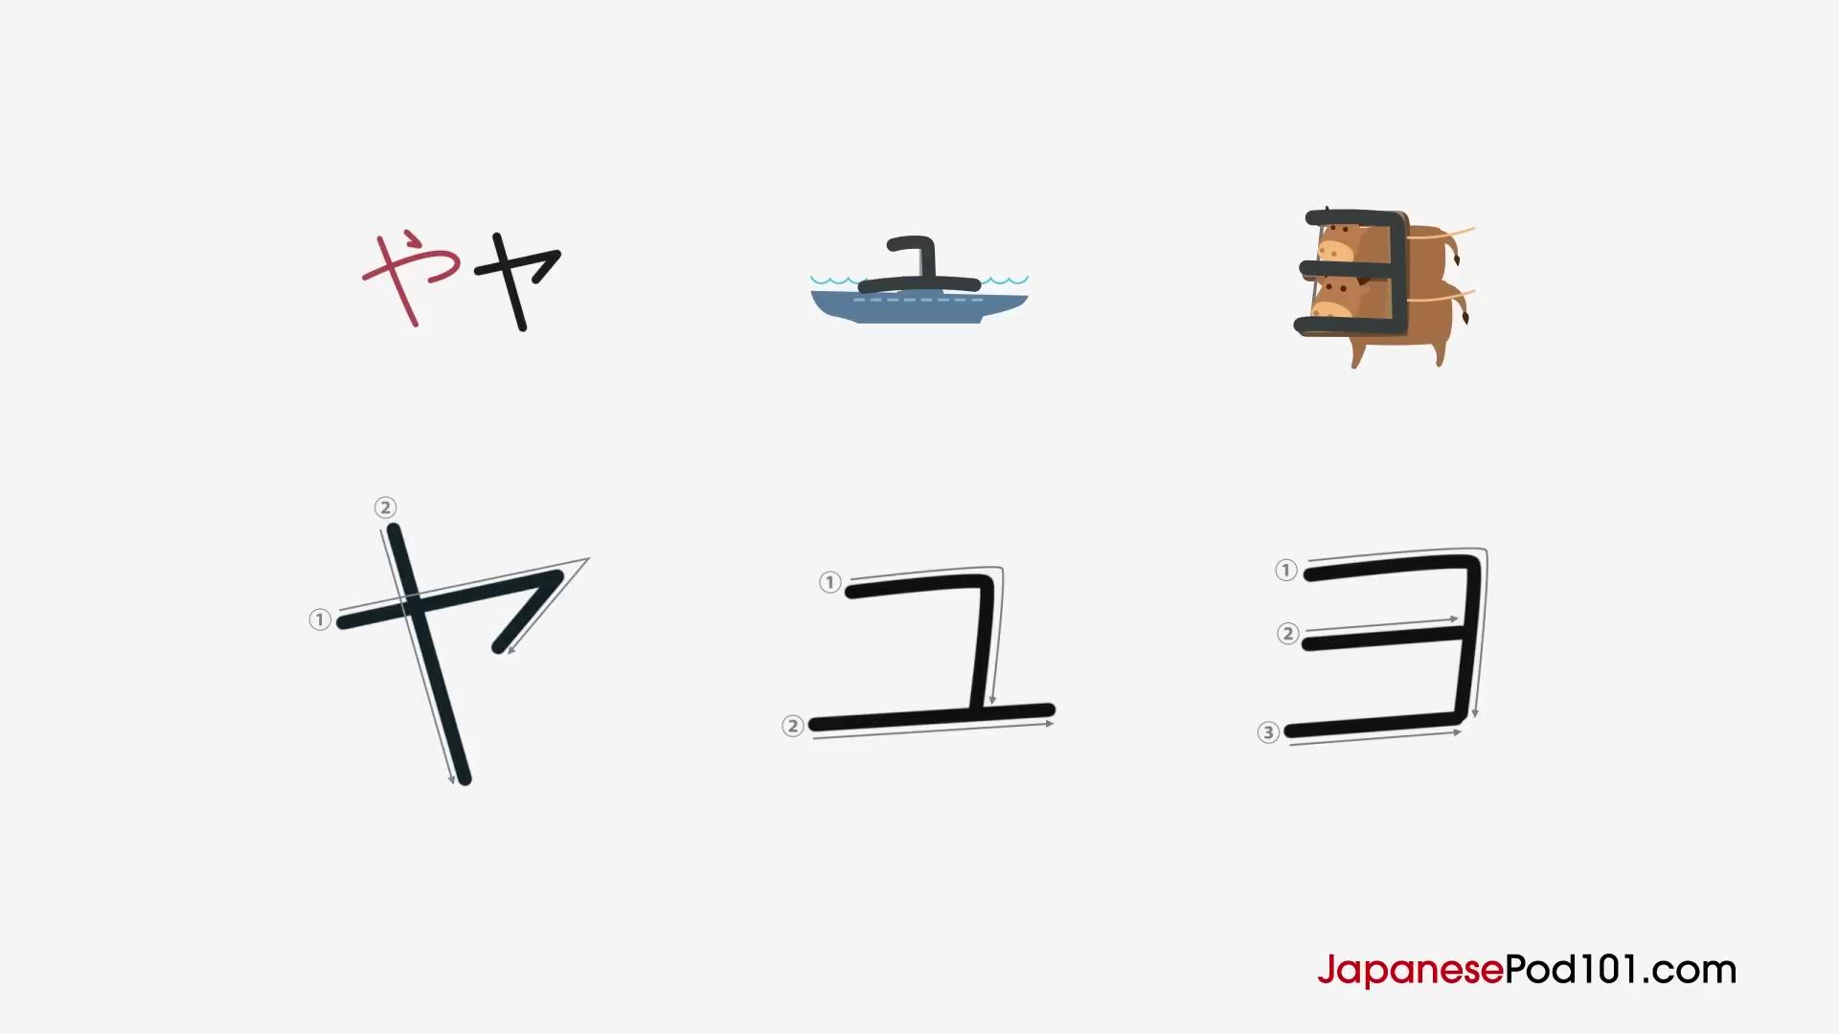
ヤ (ya)
Mnemonic: Angular version of や.
ユ (yu)
Mnemonic: A periscope of a submarine.
ヨ (yo)
Mnemonic: Something pulled by oxen.

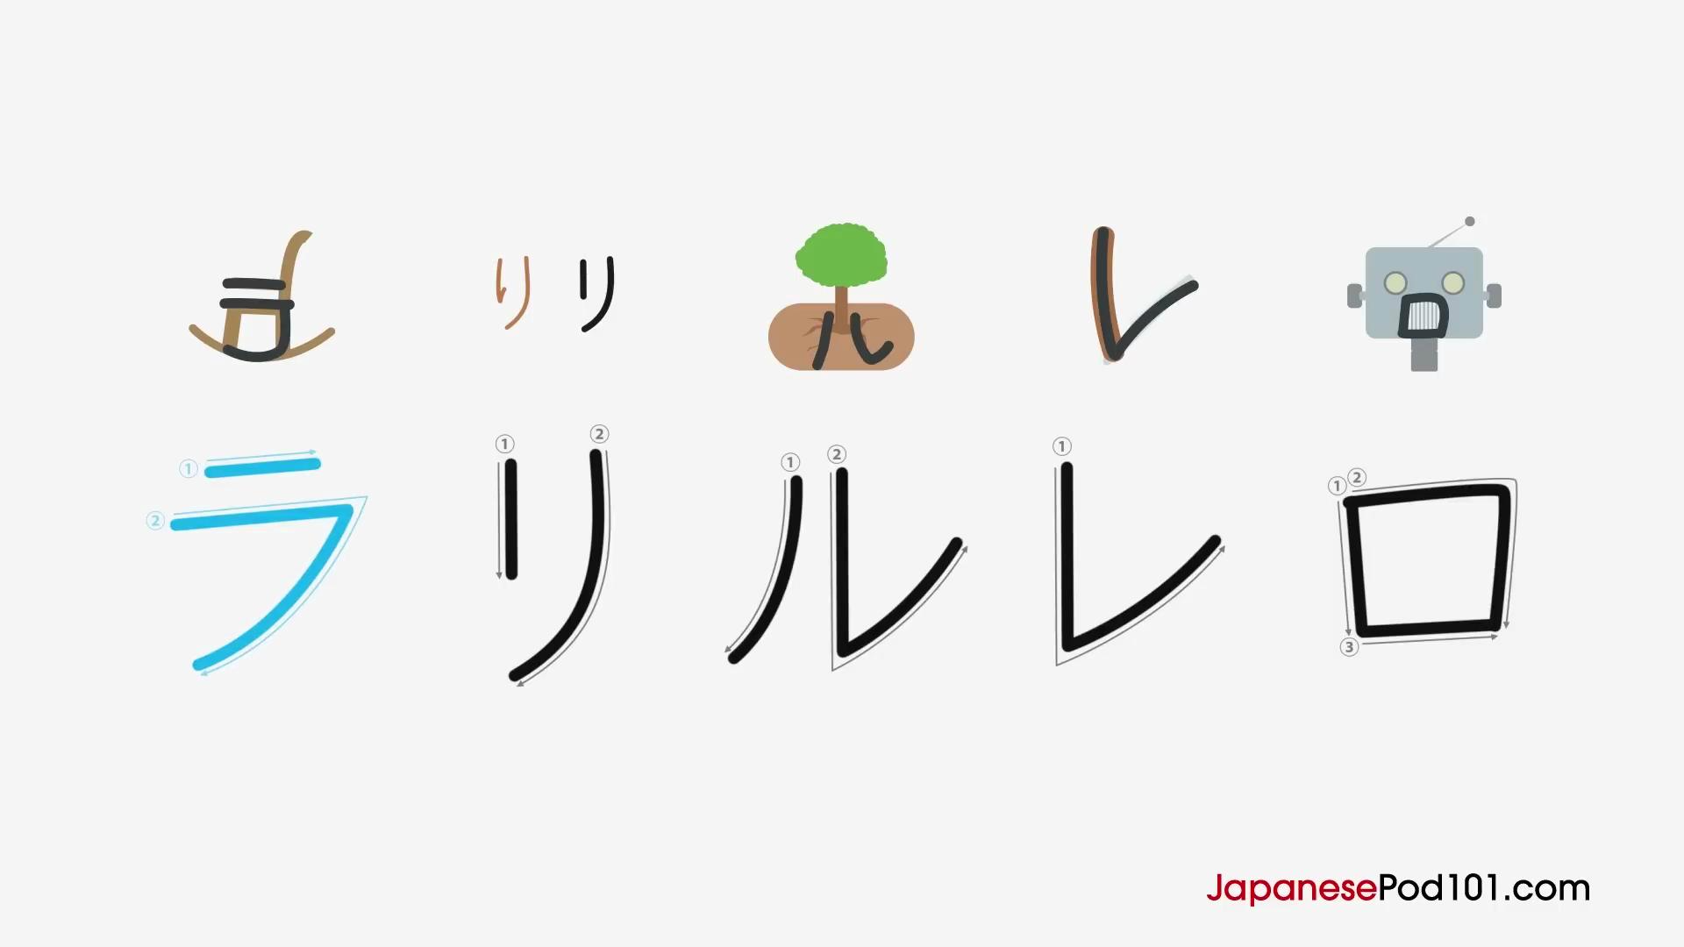
🔤 R Column
ラ (ra)
Mnemonic: A lounge chair.
リ (ri)
Mnemonic: Simplified り.
ル (ru)
Mnemonic: Roots of a tree.
レ (re)
Mnemonic: A razor blade.
ロ (ro)
Mnemonic: A robot’s mouth.

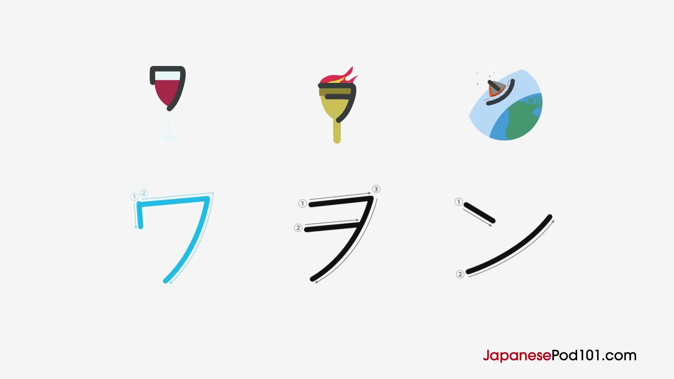
🔤 W Column
ワ (wa)
Mnemonic: A wine glass.
ヲ (wo / o)
Mnemonic: Part of an Olympic torch.

🔤 N (đặc biệt)
ン (n)
Mnemonic: A spacecraft entering atmosphere.

